Chemical and Petroleum Engineering Graduate Conference
University of Calgary
May 23, 2024

Requirements for successful CO₂ reduction in Alberta using solar and storage-battery power sources

Kevin Dorma, Ph.D., P.Eng. (AB, MB), President, Kevin Dorma Consulting

Abstract

Electricity production is a significant source of CO2 emissions in Alberta. The specific emission intensity from power generation has been cut in half over the last 30 years. This is attributed to phasing out coal, adding efficient natural gas fired facilities and a significant investment in wind turbines. We need to further reduce our carbon footprint to produce electricity. The technologies most often considered are solar, wind, cogeneration and battery storage. Are there specific requirements where these technologies will be successful in reducing CO2 emissions? We will use the First Law of Thermodynamics (Conservation of Energy) to evaluate solar and electricity storage in the context of reducing CO2 emissions. We will answer three questions:
- Does the technology decrease or increase the carbon footprint?
- Is the technology effective in Alberta but ineffective elsewhere?
- Is the technology ineffective today but effective tomorrow?

This keynote address was presented at the Chemical and Petroleum Engineering Graduate Conference at the University of Calgary, May 23, 2024.

Introduction
There is a huge push for society to reduce CO2 emissions. The environmental topics today describe innovative technology for accomplishing this goal. My topic is not innovative. Instead, we will look at two standard sources of renewable electrical power: solar and battery storage. Over the next 20 minutes I will answer the question on “Where should we apply existing technology?”, not “Can we build new technology?”. We will explore which technologies are successful at reducing our carbon footprint and which are not.

Why should we look at this? Perhaps because we work at a large company, and we are asked to provide a renewable energy plan for different sites across the country. Maybe we sit on a governance board for a non-profit group, and they want to develop an energy policy. As graduates with expertise in Energy Balances, we can use our knowledge of thermodynamics to guide us and make suitable recommendations.

Fundamentals
Alberta uses several different technologies for supplying electrical power to the grid. Different types of natural gas fired generators provide most of our power [1].

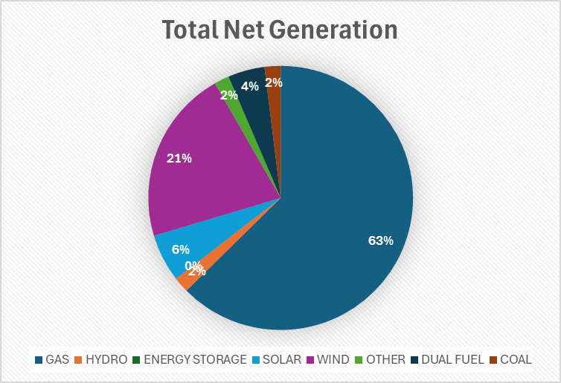
Electrical generation sources on May 8, 2024 (morning), from AESO [1].

Summary of Net Generation (May 8, 2024)
Source |  | Contribution to Demand
Gas |  |  | 63%
 | Cogeneration | 56%
 | Combined Cycle | 24%
 | Gas Fired Steam | 13%
 | Simple Cycle | 7%
Coal |  |  | 2%
Dual Fuel |  |  | 4%
WIND |  |  | 21%
SOLAR |  |  | 6%
HYDRO |  |  | 2%
OTHER |  |  | 2%
ENERGY STORAGE |  |  | 0%

Our demand for electricity varies over the day, and over the year. Our peak daily demand usually occurs between 4:00 PM and 8:00 PM, and electricity demand is higher in cold weather.

Electrical power supply must always balance the demand: this is a statement of the First Law of Thermodynamics (conservation of energy). If the demand increases, then the supply must also increase. However, not all electrical sources can increase or decrease the supply quickly to satisfy changes in demand.

A balance.

We will define three different categories for electricity supply, based on the role that the supply has in balancing with demand:

Base | Opportunistic | On-Call
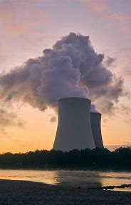 | 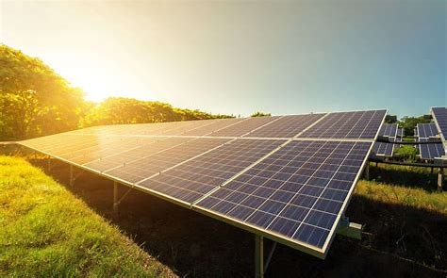 | 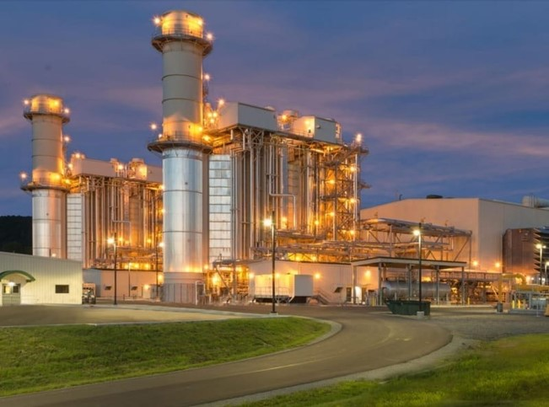

A nuclear power plant provides a Base supply. This is a large amount of electricity where the supply does not change very much over a day or perhaps over the year. We are not interested in base supplies.

Most of our renewable sources are Opportunistic. These provide electricity during conditions that we cannot control. Solar only provides power when the sun shines, and turbines only provide power when the wind blows. An interesting source in this category is Cogeneration: this is where the waste heat from a natural gas fired power plant has a useful purpose in a manufacturing process. The amount of power generated by the plant depends on the amount of heat demanded by the process. While Cogeneration is very important in Alberta, we don’t have the time to review this today.

We need power sources that we can adjust. We will have power outages if Demand exceeds Supply. Most of our gas fired power plants provide this On-Call supply: if we need more electricity, we can burn more fuel in the power plant. Another source of On-Call power is electricity that is stored in large banks of Storage Batteries.

On-Call power sources are the most important because these keep our lights on.

We need a control volume to apply the principle of Conservation of Energy. Our control volume will be drawn around the Base, Opportunistic, and On-call sources.

We will consider Solar (Opportunistic) and Battery Storage (On-call) to determine how these technologies reduce our carbon footprint.

Solar
Solar panels are becoming very popular in Alberta. The picture below shows the installation of solar panels on a church in Alberta. Let’s apply the Conservation of Energy to see how this solar panel impacts our CO2 emissions for the province.
      - Sunlight reaches the solar panel.
      - Panel converts light to electricity.
      - The panel is a source of electrical power to the Alberta power grid. Power supply to the grid increases.
      - To maintain constant total power supply on the grid, an On-Call supply must decrease its supply of power.
      - The On-Call supply is a gas fired generator, which responds by consuming less fuel to supply less power to the grid.
      - Less natural gas consumption results in lower CO2 emissions.

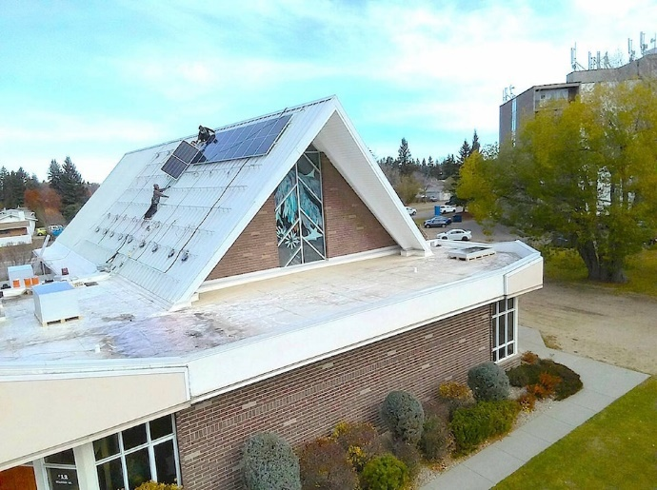

The On-Call gas fired generator is needed to keep our lights on. The Solar panel reduces the amount of electricity that we need from the gas fired generator. The replacement of On-Call power with Solar is another statement of Conservation of Energy.

Every solar panel in Alberta results in lower CO2 emissions for the province. But what if the solar panel is installed on a different power grid? Consider a similar solar panel installed at a similar church in BC.
      - Sunlight reaches the solar panel.
      - Panel converts light to electricity.
      - The panel is a source of electrical power to the BC power grid. Power supply to the grid increases.
      - To maintain constant total power supply on the grid, an On-Call source must decrease its supply of power.
      - The On-Call source is a large Hydroelectric generator. Less water is delivered through the turbines. There is no reduction in fuel consumption in BC.
      - CO2 emissions remain constant.

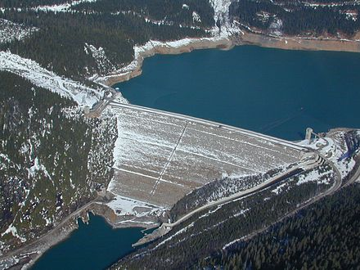
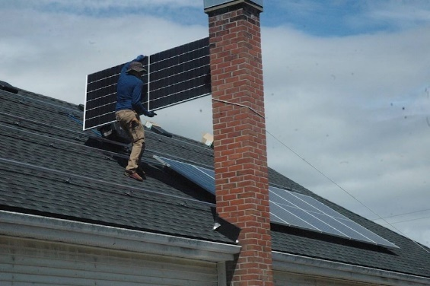
Solar panels only reduce our carbon footprint if they are connected to power grids where the On-Call power sources consume fossil fuel. A solar panel has no impact on carbon emissions if it is installed on a power grid that is dominated by hydroelectric sources. I think there is a legitimate reason for installing solar panels in BC, but it is not for reducing CO2 emissions.

Battery Storage for Solar

Now let’s consider a rather new way of using Opportunistic sources (such as Solar): battery storage. For simplicity we will consider the fictional case where our power grid is supplied by Solar (average 100 MW output) and On Call Gas Fired generators (average 100 MW output).

Now let’s consider that all of the Solar power is stored in Storage Batteries to deliver the power when it is needed most. A storage battery is roughly 90% efficient [4]: of the 100 MW of power that is delivered to the battery from the solar panel, 10 MW is lost as waste heat, and 90 MW is delivered to the grid.

Since our total demand is still 200 MW, the On-Call supply must provide an additional 10 MW of power to account for the energy lost in the storage battery. This means that additional gas must be fired to generate power. Battery storage increases the provincial CO2 emissions.

We must compare the performance of battery storage with other options to meet our peak demand. A Simple Cycle Gas Turbine is often used for this purpose. The efficiency of a simple cycle gas turbine is near 40% [3], similar to battery storage. However, there are some advantages to the Simple Cycle gas turbine:
- Roughly 30% lower capital cost [5].
- Does not require time to charge.
- Provides power indefinitely whereas the battery eventually runs out.

Battery storage charged by Combined Cycle process has similar CO2 emissions compared to a Simple Cycle gas turbine. I would prefer a gas turbine over a battery due to the reliability of the power supply.

Under what conditions would a storage battery reduce our CO2 emissions? Consider the case where we have a surplus of renewable power. This means there are times where we have an excess of renewable electricity and all our gas fired generators are on STANDBY. Now we have the right conditions to store surplus power and deliver it to the grid later. This reduces our consumption of natural gas.

Summary
- Energy utilization can be a difficult concept to grasp.
- There is no one-size-fits-all solution.
- Good solutions depend on the existing electrical power infrastructure. This depends on location, and changes over time. A good solution in Alberta may be a bad solution in BC. A bad solution today can be a good solution tomorrow.
- We need to apply our best teaching skills to share these concepts with others. Otherwise, we will be wasting resources that should be used to reduce our consumption of fossil fuels.

References
      - AESO data. Home » AESO
      - CCGT efficiency. An Overview of Combined Cycle Power Plant (electrical-engineering-portal.com)
      - Efficiency gas turbine. Combustion engine vs. Aeroderivative gas turbine: Part-load efficiency - Wärtsilä Energy (wartsila.com)
      - Battery storage round trip efficiency. Utility-Scale Battery Storage | Electricity | 2022 | ATB | NREL
      - Capital Cost of power plants. Cost and Performance Characteristics of New Generating Technologies, Annual Energy Outlook 2022 (eia.gov)

